**Northern Gateway Area Action Plan – Options Document**

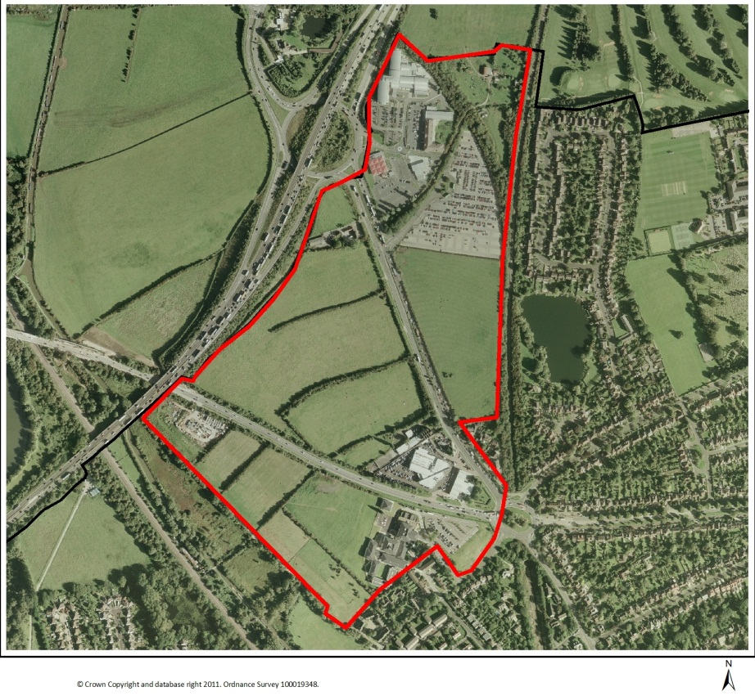

**Foreword**

The vision for the Northern Gateway is to create an employment area which will build on the strengths of Oxford’s economy in the key sectors of education, health, research and development, and knowledge-based businesses. The development of the Northern Gateway offers the opportunity for existing and new firms to relocate and ensure that Oxford’s economy continues to grow. There is scope for the provision of new residential accommodation to help meet Oxford’s housing needs and also some complementary uses, which may include retail and hotel use, to enhance the sense of place and add vitality and sustainability.

This development provides an opportunity to bring benefits to neighbouring communities. Significant resources will be directed to improving the local highway and footpath/cycle network to benefit users of all forms of transport. This will include capacity improvements to both the Wolvercote and Cutteslowe roundabouts and the provision of a new link road between the A40 and A44 to remove much of the through traffic from the area and to improve the character and local environment along these main roads. The new employment opportunities and community facilities will benefit new and existing residents alike.

To take this project forwards we are working closely with a range of stakeholders and importantly with the County Council. We are very keen to involve the local community in drawing up plans for the area. We want to hear the ideas of as many people as possible so that the best solution is found, not just for the new residents but for the existing communities too.

**Introduction**

**What is an Area Action Plan?**

We will be producing an Area Action Plan (AAP) to guide the future development and changes at the Northern Gateway. AAPs focus on the implementation of policy in a specific location. They are an important way of ensuring development of an appropriate scale, mix, and quality for key sites. The AAP will look at things such as what transport improvements will be required, what mix of flats and houses there should be, and what community facilities will be needed. It will also look at how the development relates to, and links with, neighbouring communities. By guiding the types of development to take place, and setting out when and how the development will take place, the Area Action Plan will become the key document through which the vision and objectives for the Northern Gateway can be secured and achieved. The boundary will define the area that the policies of the AAP will relate to; planning applications inside the boundary will be assessed against them. Inclusion within the boundary does not signify that a property will necessarily be subject to change; the boundary has no impact on land ownerships for example.

**What is an Options Document?**

An Options Document is one of the steps along the way towards an AAP. This document details and offers for consultation the options and suggestions generated so far in the production of the AAP. The City Council has already undertaken a considerable amount of background work and collaboration with partners, local people, businesses, and others with an interest in the future of Oxford. This background work has enabled the City Council to put forward draft development principles, policies and options for consultation. The most promising options that were identified for the AAP have been included in this document. They have been assessed in a Sustainability Appraisal report, which accompanies this document. However, it is still necessary to assess which options or combination of options is most appropriate for the Northern Gateway. Alongside the consultation on this document, and the Sustainability Appraisal work, technical studies will be carried out to determine which options to pursue in the final AAP.

**How is the document structured?**

* Context: describes the current situation in the area and the proposed role of the site in the wider city context
* Vision and objectives: identifies aims for the project
* Options: the document examines the options for development and options for the ways to meet the objectives
* Delivery: considers how to implement the strategy and outlines what infrastructure would be needed

**Context**

**Policy Context:**

The City Council has to provide more housing and employment, so it produced a Core Strategy to work out where and when this can be built. The development site at Pear Tree has been identified for some time as being capable of providing for long term growth. This site was allocated as a strategic development site in the Core Strategy called the Northern Gateway, this means that the Northern Gateway must be developed in order to deliver the Core Strategy and that no development on this site is not an option that can be taken forward.

The Core Strategy allocates the site for an employment-led development providing around 55,000m2 of space for science, research and development and/or university spin-off companies up to 2026 (the end date of the Core Strategy) but up to 80,000m2 in total including development after that date. In addition the allocation would allow any of the following: an emergency services centre, 200 residential dwellings, small retail units and a hotel.

The Core Strategy clearly states that development will be expected to incorporate a package of transport measures including capacity improvements to roads and junctions and demand management measures to mitigate the impact of the development on the local and strategic road network. Importantly these improvements would be tied to phases of the development to ensure that the infrastructure is provided in advance and alongside the development.

In addition, the residential element of the development would be required to be planned in such a way as to ensure that future residents benefit from a good quality living environment and that the new community is supported with the required amenities such as provision of school places and open space.

**Site Context:**

The aerial photograph on the cover shows the site. It includes the service area at the Pear Tree roundabout and the Park and Ride site, the fields to the south, (including both sides of the A44 and A40), and the commercial properties at the Wolvercote roundabout. This does not mean that these facilities will be lost, rather that in planning the development, the site needs to be considered as a whole in order to offer the best options for development. The site within the AAP boundary is approximately 44 hectares.

The main land uses in the area include; agricultural grazing, the Pear Tree Park and Ride site, and the service area.  The wider area also includes a range of commercial enterprises, close to the Wolvercote roundabout.  There is a small area of Green Belt land at Pear Tree Hill Farm and a larger area of Green Belt land to the south of the A40.

The area has been assessed as having low landscape quality, biodiversity interest and historic integrity[1].  Despite this, the area is in a visually sensitive location, at the gateway to Oxford from the north.  It also forms a setting to Wolvercote Conservation Area, the historic Goose Green and the Thames floodplain, and for these reasons its sensitivity may be described as moderate.  Goose Green is a registered common and is an important open space in the area, which needs to be protected from development.

The land is entirely within Flood Zone 1.  The city-wide Strategic Flood Risk Assessment (SFRA) was reviewed in 2011.  As a result of this review, a part of the site is suspected to be prone to surface water flooding.  The site itself is of relatively low ecological value however 500m from the site boundary is the internationally protected Oxford Meadows Special Area of Conservation (SAC).  The Oxford Meadows SAC is protected because of the habitats, (lowland hay meadows), and rare plant species, (creeping marshwort *Apium repens).*

The main constraint to development relates to access and traffic generation.  The area around the Northern Gateway experiences significant peak-hour congestion and a package of highways and transport mitigation measures will need to be found and funded.

**Vision and Objectives**

**The vision:**

In 2030, the Northern Gateway has become a vibrant and successful extension to Oxford. It is a flourishing community for knowledge-based industries. Co-location of new and growing businesses, close links to the universities and hospitals and a high quality working environment have helped foster a creative atmosphere where innovation thrives.

Attractive new buildings, streets and open spaces add to its strong local character, making it a distinctive part of the city. The emphasis on quality and sustainability has made it an example for other new communities in the 21st century.

Modern new homes with access to community facilities and open spaces have also made this a desirable place to live. The mix of housing has helped to encourage a balance of residents, with young and old, families and singles living together. New amenities provide a focus for the community, providing a range of facilities and services for local people. This complements the facilities available in neighbouring areas for the benefit of the wider community.

The Northern Gateway development helped deliver key improvements to the local transport network and enabled the securing of funds to provide wider transport improvements to the strategic network. On foot, bicycle and public transport, the area is now well connected with surrounding communities and the city centre, linking places of work and homes.. Pedestrian routes linking open spaces and community facilities are safe and easy to use.

**Objectives for the Area Action Plan:**

The objectives will be the keys aims of the project and a way to measure success or failure.

**Objective 1 – Strengthen Oxford’s knowledge-based economy**

Providing additional floor space related to Oxford’s key strengths in science and technology, research and development, and/or non-teaching university development, will strengthen the city’s economy and help deliver a nationally important ‘knowledge economy spine’ for Oxfordshire.

**Objective 2 – Provide more housing**

The project provides the opportunity to deliver additional housing including affordable housing to help address the need in Oxford. The housing will need to be designed in a way that provides an attractive living environment and supports a strong community feel with access to the necessary amenities.

**Objective 3 – Improve the local and strategic road network**

The site is adjacent to three strategic roads and the area already experiences congestion. Development of the site will help to facilitate a package of improvements to the local and strategic road network whilst also ensuring that the impact of the development is mitigated. It will be important to integrate the development with the rest of the city, particularly with good pedestrian, cycle and bus links.

**Objective 4 – Respond to the context of the natural and historic environment**

It is important to consider the context of the development in terms of the natural and historic assets of the site and locality. New development should respond positively to its surroundings.

**Objective 5 – Create a gateway to Oxford**

The site is at a strategically important position at the northern entrance to the city and offers the opportunity to create a high-quality gateway. Careful attention to the urban design of the site and the architectural design of the individual buildings will be important to help create a positive and distinctive sense of place.

**Objective 6 – Encourage a low-carbon lifestyle/economy**

This development will be planned with the future in mind. It will be important to include features which will encourage new residents and businesses to adopt a “low-carbon” lifestyle. The development should encourage use of sustainable modes of travel and energy efficiency measures and renewable energy.

**Options**

**Balance and mix of uses:**

One of the key decisions that the AAP will make will be about the type of land uses that will be permitted at Northern Gateway and the balance to be struck between those uses.

**Type of employment**

The starting point for this decision is the Core Strategy allocation. Within the context of the city as a whole, it has already been established that the Northern Gateway site should have an employment focus. This in turn should build on the strengths of Oxford’s economy in the key sectors of education, health, research and development, and knowledge-based businesses. It will be important that this is not a generic business park, but one that is closely tied to the innovation and knowledge economy.

The Oxford Employment Land Study identified the safeguarded land at Pear Tree as the *“principal opportunity to meet Oxford’s future employment needs”*. Whilst this study is now seven years old and pre-dates the credit-crunch, the authors’ state: “*this longer timescale would be expected to cover different economic cycles, including periods of both economic downturn and stronger growth, the forecasts have reflected this.”[2]* The Oxford Economic Growth Strategy was produced earlier this year to provide an updated analysis of Oxford’s economy, it states: “*Oxford is a national asset and essential to the future of the UK and the regional economy as a whole*.” and describes the city as “*the engine of Oxfordshire’s economy*”. In October 2013 the University of Oxford published a report by SQW which sets out the role and contribution the University makes to the city, regional and national economy. This report states that, “*Oxford has to grow to fulfil its role within the high tech economy*.” The consultants consider the, “*greatest potential for sustainable growth is to the north of the city around Begbroke, the new Northern Gateway (Peartree) and the planned new rail station at Water Eaton*.”[3]

The thread running through all these studies is that if Oxford is going to continue to have an important role in these sectors nationally, it is important that there are opportunities within the city to provide more floor space to support them. The development of the Northern Gateway offers the opportunity for existing and new firms to relocate and ensure that Oxford’s economy continues to grow.

**Type of employment:**

|  |  |
| --- | --- |
| Preferred Option | Ensure the employment development directly relates to the knowledge economy of Oxford (science and technology research, bio-technology and spin-off companies from the universities and hospitals) |
| Alternative Option | Ensure that a set proportion (for example 85%) of the development directly relates to the knowledge economy of Oxford |

**Primary uses**

The primary focus for this site is to provide significant levels of employment generating uses, with complimentary housing. It will be particularly important to create the right balance and mix of these uses to ensure that it contributes effectively towards meeting the city’s varied needs but also forms a sustainable and vibrant new area of the city in its own right – an area that people will want to live and/or work in.

Oxford’s need for more housing is well established and documented; the Oxfordshire Housing Market Assessment[4] concludes that there is a need for 64,189 new dwellings in Oxford over the next 10 years in order to meet demand. This equates to an annual average demand of 6,418 dwellings. Considering that the current number of dwellings in Oxford is 54,546 dwellings, to meet demand would mean at least doubling the size of Oxford as it currently stands. Oxford would never be able to match this need within its boundaries due to its scale. The Oxfordshire Housing Market Assessment is currently under review and when complete will provide an up-to-date picture of the housing need of the city (and more widely, the county). This new work is likely to demonstrate that the housing need is far greater than Oxford can physically provide in a sustainable manner.

Whilst the focus is on employment development, given the scale of the need for additional housing in the city it is clear that if an element of housing can be provided alongside the employment uses it would be of benefit to the city as a whole. Beyond this strategic objective, introducing an element of residential use to a site that is mainly occupied during office hours would add to the vibrancy and vitality of the development.

**Primary mix:**

|  |  |
| --- | --- |
| Preferred Option | Maintain an employment focus for the site whilst achieving good levels of housing provision |
| Alternative Option 1 | Reduce focus on employment uses and increase the levels of housing provision |
| Alternative Option 2 | Reduce provision of housing and maximise development of employment uses |

Detailed design work will be required to establish the actual capacity of the site and how much of each of these uses can be delivered without compromising the quality or functionality of the development. This work will follow at later stages of the AAP process. However looking at each of these uses in principle we can start to explore the likely scale of provision even if framed within ranges.

**Scale of employment uses:**

|  |  |
| --- | --- |
| Preferred Option | Place no upper limit on the quantum of employment development but leave it to design constraints to determine the appropriate level |
| Alternative Option 1 | Provide up to 80,000m2 of employment development (based on that indicated in the Core Strategy) |
| Alternative Option 2 | Provide up to 55,000m2 of employment development (based on policy allocation up to 2026 in the Core Strategy but without the indicated development beyond that) |
| Alternative Option 3 | Provide up to 90,000m2 of employment development (based on the Core Strategy indication and an additional 10,000m2 as alternative to emergency services centre) |

**Scale of residential uses:**

|  |  |
| --- | --- |
| Preferred Option | Provide a mid-sized residential development (e.g. up to 500 homes) |
| Alternative Option 1 | Provide a smaller number of homes (e.g. up to 200 homes, based on the policy allocation up to 2026 in the Core Strategy) |
| Alternative Option 2 | Provide a larger number of homes (e.g. up to 800 homes) |

**Secondary uses**

A secondary consideration is what additional or supporting uses should be provided. The Core Strategy allocation would permit any of the following: an emergency services centre, hotel with leisure uses and small scale retail facilities. Introducing other small scale uses alongside the primary mix would offer new employees and residents the opportunity to access facilities and services locally. This would help to make the main development more sustainable and also add extra vitality to the site.

**Retail uses:**

|  |  |
| --- | --- |
| Preferred Option | Provide small retail units of an appropriate local scale on the site (e.g. up to 2,500m2 gross floorspace) |
| Alternative Option 1 | Remove the retail uses to facilitate more development of the primary uses |
| Alternative Option 2 | Provide for a mid-sized supermarket on the site (e.g. around 4,000m2 gross floorspace) |
| Alternative Option 3 | Provide for a mid-sized supermarket (e.g. around 4,000m2 gross floorspace) and some smaller retail units (e.g. up to 2,500m2 gross floorspace) |

**Hotel with leisure uses:**

|  |  |
| --- | --- |
| Preferred Option | Provide for a hotel on the site (e.g. up to 180 bedrooms) with associated leisure facilities (e.g. restaurant and gym) |
| Alternative Option | Remove the hotel to facilitate more development of primary uses |

**Emergency Services Centre:**

|  |  |
| --- | --- |
| Preferred Option | Remove the emergency services centre to facilitate more development of primary uses |
| Alternative Option | Provide for an emergency services centre on the site (e.g. up to 10,000m2). Make policy provision for this allocation to revert to employment use if not delivered by a particular phase of the development. |

**Education**

When planning for a new community it is clearly important to plan for the necessary supporting amenities that will make the community more sustainable and desirable. There is a range of facilities and services within reach of the site particularly within neighbouring residential areas and Summertown District Centre. Ease of access to school places for additional children who will be resident in the area needs to be secured. In their role as Local Education Authority the County Council have assessed the likely numbers of pupils that will come forward from the Northern Gateway in a range of development scenarios. This calculation has then been used in conjunction with an assessment of current school capacities and likely development from other sites in the area, to assess whether pupils from the Northern Gateway could be accommodated in existing schools (albeit expanded) or whether an additional school will be required. This work indicates that only if 800 homes are provided within the site will a new on-site primary school be required. With development of 200 or 500 homes, the new pupils can be accommodated within expansions of existing schools (Wolvercote Primary and Cutteslowe Primary) even taking into account development elsewhere, for example at the Wolvercote Paper Mill site. Cutteslowe Primary School has already been approved for expansion to become a 2 form entry school, and would not be expanded further. Wolvercote Primary School has existing approval for expansion to become a 1.5 form entry school and there is potential for further expansion in the future for it to become a 2 form entry school.

**Existing built areas of the site**

Within the AAP boundary there are two main areas of existing built development, the hotel, showroom and petrol station at the Wolvercote roundabout, and the services area on the Pear Tree Interchange. The fact that these areas are within the AAP boundary does not necessarily mean that these facilities will be lost, but that in order to find the best solution for development, the whole site needs to be considered.

The commercial properties at the Wolvercote roundabout have seen investment in recent years and it is unlikely that these properties will come forward for redevelopment in the near future. However they clearly occupy prominent positions on the edge of the Northern Gateway site and may come forward for redevelopment or further refurbishment in the long term and therefore may offer further opportunities for the future.

The Pear Tree Services Area performs an important function at its location on the A34 Pear Tree interchange. It consists of a range of buildings and facilities that have been developed incrementally over the years, including two hotels, a petrol station and the services building. It is unlikely that either of the hotels will come forward for development in the near future. It may be possible however, to redevelop the services building and the associated car park area. Redevelopment would be beneficial to improve the facilities and help enhance the “gateway” effect of the Northern Gateway development.

**Services Area:**

|  |  |
| --- | --- |
| Preferred Approach | Encourage refurbishment of the services area to further enhance the approach to the city |

**Housing mix**

In addition to the need for new housing in Oxford, there is a specific additional need for more affordable housing (whether social rented, intermediate, shared ownership or affordable rented housing[5]). Across the city the approach is taken to require a minimum of 50% of dwellings to be provided as affordable homes, with 80% of those provided as social rented with the remainder as intermediate housing. This policy contains a cascade approach that can be used when this policy requirement makes the development unviable.

**Affordable housing:**

|  |  |
| --- | --- |
| Preferred Approach | Use the existing planning policies of requiring at least 50% of homes to be affordable |

**Dwelling sizes**

In order to ensure that there is not a mismatch between the type of housing that is developed and the identified need in the city, the City Council also applies a balance of dwellings policy. This takes of the form of specifying a percentage range for each size of home. A specific mix of housing has been established for large strategic sites as set out in the Preferred Option below.

**Dwelling sizes:**

|  |  |
| --- | --- |
| Preferred Option | Use existing policy approach (as set out in Balance of Dwellings SPD)  1 bedroom homes: 10-15%  2 bedroom homes: 25-30%  3 bedroom homes: 40-55%  4+ bedroom homes: 10-15% |
| Alternative Option 1 | Increase the proportion of smaller (1 and 2 bedroom) homes |
| Alternative Option 2 | Increase the proportion of larger (3 and 4+ bedroom) homes |

**Transport:**

The area around the Northern Gateway already experiences significant peak-hour congestion due to the volume of traffic and the convergence of the A40 and A44 at the Wolvercote roundabout and close proximity of the A34. There are also concerns with local access and environmental issues such as noise and air pollution. A Baseline Transport Report[6] has been produced to assess the existing transport situation in terms of traffic counts, queue lengths, bus service provision and accident data for example.

Work to support the Core Strategy and an earlier project called “Access to Oxford” sought to develop a package of highway improvements for the area. That work is being reassessed as part of the AAP process. In essence a large package of transport measures will be required to work together to facilitate development of the Northern Gateway and mitigate existing concerns in the area. This package of measures will be expensive and will require funding to be secured from a range of sources including the development itself, local transport funds and central government funding. (Also see section on implementation and delivery below.)

**Access and highways measures**

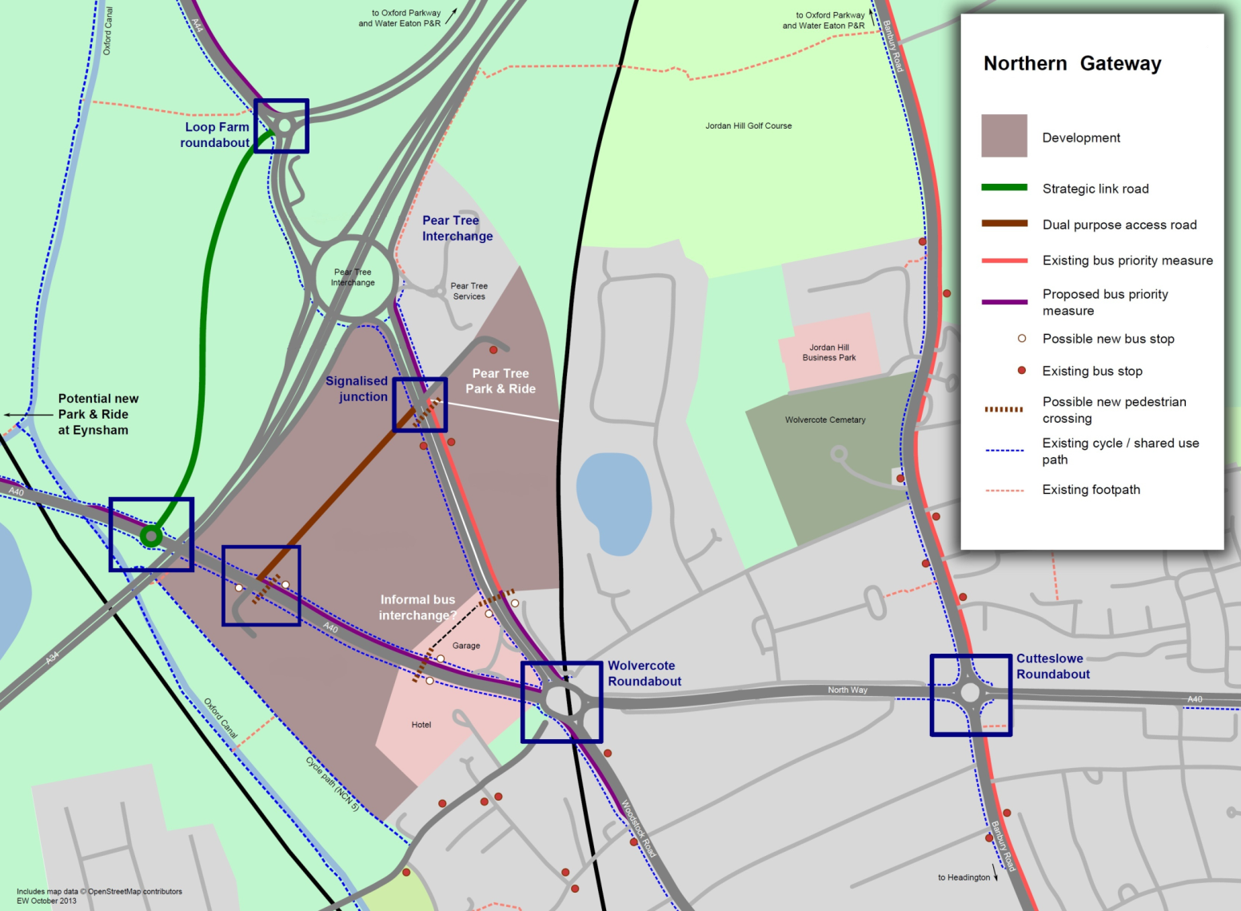

The A40 and the A44 run through the Northern Gateway site and currently act as barriers to integrating the individual areas of the site. Both these roads are important elements of the highway network and are currently only designed with vehicle users in mind. These roads bisect the Northern Gateway site, acting as barriers to pedestrians and cyclists in particular. The character and barrier effect of these roads need to be addressed as part of the development without compromising their roles in the highway network.

One aspect of changing this character will be providing an alternative route for longer distance through traffic, removing it from much of the length of the existing roads through the site. At present traffic from the Witney direction on the A40 wanting to join the A34 has to travel to the Wolvercote roundabout and then travel back out on the A44 to the Pear Tree Interchange. As part of the Northern Gateway development there is the opportunity to provide a link road through the northern part of the site between the A40 and A44. The effect of this would be to remove much of the through traffic from both roads and to reduce traffic flows at the Wolvercote roundabout. The form of development provided along the length of these roads will also have an important impact on the character of the area. Further improvements could be achieved in the wider area through the provision of a strategic link road to the West of the A34, creating a link between an enlarged Loop Farm roundabout and a new roundabout on the A40. Such a scheme could further ease congestion on the A40 approach and the Wolvercote Roundabout.

The major cause of congestion on the A40 is the volume of traffic compared to the capacity of the junctions at Wolvercote and Cutteslowe. Significant congestion occurs on the approaches to Wolvercote roundabout, particularly eastbound during the morning peak. Cutteslowe roundabout is also at capacity but due to the congestion at Wolvercote, eastbound A40 traffic is held up on its approach to Cutteslowe roundabout, limiting the length of queues building up here. If additional capacity is provided at Wolvercote roundabout, congestion could worsen at Cutteslowe. This highlights that access and highway improvements in the vicinity of the Northern Gateway need to be treated as an integrated package, as set out in the options below. The Preferred Option identifies a package of measures that would provide a full transport solution to the wider area (including Northern Gateway mitigation measures); the Alternative Option identifies those measures that would be required to mitigate the impact of the Northern Gateway development but excludes those wider strategic measures.

**Access and highways measures:**

|  |  |  |
| --- | --- | --- |
| **Proposal** | **Preferred Option**  **(full transport solution, subject to funding)** | **Alternative Option**  **(mitigates impact of development)** |
| Cutteslowe roundabout improvements | ✓ | ✓ |
| Wolvercote roundabout improvements | ✓ | ✓ |
| Full signalisation of Pear Tree roundabout | ✓ | 🗶 |
| Partial signalisation of Pear Tree roundabout | 🗶 | ✓ |
| Construction of off-site strategic link road between the A40 and A44 (Loop Farm roundabout) | ✓ | 🗶 |
| Construction of dual-carriageway on-site link road and site access road with junctions to A40 and A44 | 🗶 | ✓ |
| Construction of single-carriageway site access road with junctions to A40 and A44 | ✓ | 🗶 |
| Secondary site access from A40 & A44 | ✓ | ✓ |
| Public realm and environmental improvements to A40 and A44 | ✓ | ✓ |

**Park and Ride**

The Park & Ride site at Peartree has just over a 1,000 spaces and is very well used. Users of the Peartree site are likely to originate from locations to the north such as Woodstock, Chipping Norton, Kidlington and Bicester and to the west, such as Witney, Carterton and Burford, – a large catchment area with a significant population. Beyond the scope of the AAP, but in terms of a wider park and ride strategy, providing additional capacity to the west of the city on the A40 corridor could potentially remove more car traffic from the area.

Data[7] shows that there is a maximum of 268 people using the Park and Ride in an hour in the AM peak, and 271 people using the service in the peak PM hour. Further analysis of the data has confirmed that the majority of users access Peartree Park & Ride off the A44 corridor with a relatively small proportion via the A40 corridor which reflects the differences in accessibility from these two routes. Additional spaces at the Park and Ride site are likely to be used and this should remove more of the onward journeys into the city. The provision of the link road is likely to make the Park and Ride a more attractive option for those travelling in on the A40 who will no longer have to double-back on themselves to reach it. Whilst the Park and Ride site is a very important element of the transport strategy in the area and the city, it currently takes the form of a very large surface level car park which is not visually attractive and is a very space-hungry use of land. As part of the development it would be possible to replace the surface-level car park with a new multi-storey car park which could increase parking spaces whilst also reducing the land take, making more land available for commercial or residential development.

**Park and Ride capacity:**

|  |  |
| --- | --- |
| Preferred Option | Provide a multi-storey Park and Ride site with around 500 additional spaces |
| Alternative Option 1 | Extend the Park and Ride provision at surface level with around 500 additional spaces |
| Alternative Option 2 | Extend the Park and Ride provision further, with around 750 additional spaces in a multi-storey |
| Alternative Option 3 | Extend the Park and Ride provision further, with around 750 additional spaces at surface level |
| Alternative Option 4 | Maintain the existing level of parking provided (around 1,050 spaces) |

**Park and Ride location:**

|  |  |
| --- | --- |
| Preferred Option | Retain the Park and Ride facilities at the current location |
| Alternative Option 1 | Relocate the existing Park and Ride within the site (to opposite side of A44) |

**Public Transport**

Clearly public transport will have an important role in managing the transport impact of the proposed development. The site is well positioned and served by seven existing bus routes which primarily operate on the Woodstock Road corridor to and from the city centre. Oxford’s urban and inter-urban bus networks are known for being high quality, high frequency and experiencing continuing passenger growth. The development could provide the opportunity to build on these services and provide interchange facilities and better quality passenger facilities. In addition public transport links to the new Oxford Parkway rail station could be provided and would greatly enhance the potential for public transport interchange.

The Oxford Local Plan 2001-2016 contains a policy at TR.8 which safeguards a route through the city for the development of a guided bus/local rail service. Part of this safeguarded route lies within the Northern Gateway area; the City Council intends to remove the safeguarding of this portion of the route through the AAP process.

**Diagram of a potential public transport network**

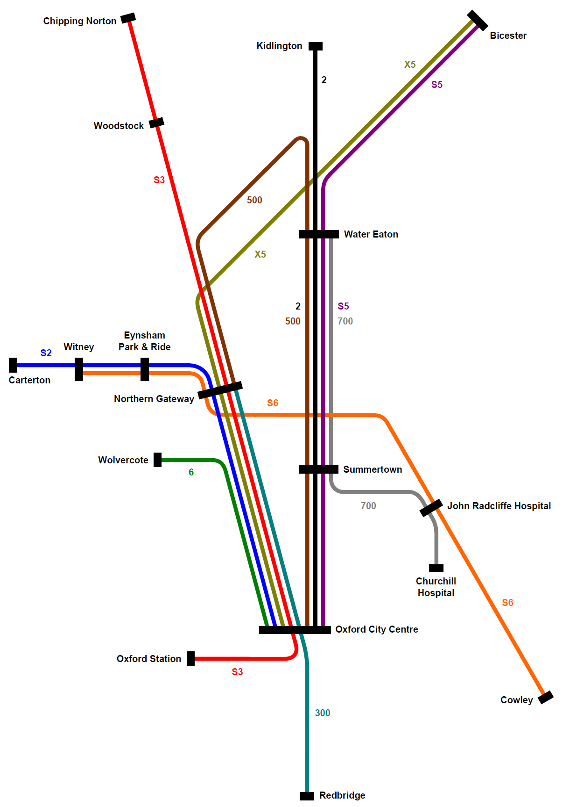

**Public Transport:**

|  |  |  |
| --- | --- | --- |
| **Proposal** | **Preferred Option (full transport solution, subject to funding)** | **Alternative Option (mitigates impact of development)** |
| Provision of enhanced bus services along A40 and A44 corridors, with connection to Oxford Parkway rail station | ✓ | ✓ |
| Provide interchange facility/bus hub in combination potentially in combination with Park and Ride improvements | ✓ | 🗶 |
| Provide new bus stops/lay-by’s and covered waiting facilities with Real Time Passenger Information (along the A40 and A44) | ✓ | ✓ |
| Widen and/or reallocate road space along the A40 fronting the site to provide priority for buses | ✓ | ✓ |
| Widen and/or reallocate road space along the A44 fronting the site to provide priority for buses | ✓ | ✓ |
| Provide for further selected bus priority measures at junctions with pre-signals | ✓ | 🗶 |
| Provide bus priority measures northbound on Woodstock Road to Wolvercote roundabout | ✓ | 🗶 |

**Pedestrian and cycle links**

Whilst the site is likely to provide employment, residential and various supporting amenities, employees and residents in particular, will need to access other facilities and communities in the local area and wider city beyond. How this integration is handled will be important so that it benefits new residents and is accepted by existing residents. Improvements to the cycle and pedestrian network in particular high quality attractive crossings of the busy roads and junctions will be an essential element of the overall transport strategy.

In considering plans and transport implications for the Northern Gateway, it is important to factor in the separate project to provide a new Oxford Parkway rail station at Water Eaton. Chiltern Railways are progressing with a new rail route between Oxford and London stopping at Oxford Parkway. This new rail service is planned to provide two direct trains every hour from Oxford Parkway to London Marylebone with the journey taking just under an hour. By December 2017 it is planned that Oxford Parkway will be served by the proposed East/West rail link to Bedford, and possibly as a later phase onto Cambridge.

It is likely that this new rail station, particularly the direct service to London will give an added attraction to the businesses and organisations locating at Northern Gateway. Given that Oxford Parkway will be less than 2 miles away from the Northern Gateway it is important to consider how passengers can easily make the journey between the site and the station. The County Council are looking at ways to secure a safe and easy pedestrian and cycle link between the two.

Provision of cycle parking is an important element in encouraging cycling as an alternative mode of travel. Cycle parking needs to be provided in the right locations, at the right levels and to a good standard to encourage cycle use. There may be an opportunity for increased cycle parking to be provided at the Park and Ride site for those who wish to park their cars and use their bikes for what is traditionally the bus leg of the journey.

**Pedestrian and cycle links:**

|  |  |
| --- | --- |
| Preferred Option | Provision of:   * high-quality, convenient cycle/footpath routes to nearby residential areas and to the service station area * improved and additional crossings of the A40 and A44 (either at surface level or grade-separated) to link development areas * good-quality, convenient routes within the development site and alongside the A40/A44 * a high-quality, convenient cycle/footpath link to the new Oxford Parkway station |
| Alternative Option | Provision of:   * high-quality, convenient cycle/footpath routes to nearby residential areas and to the service station area * improved and additional crossings of the A40 and A44 (either at surface level or grade-separated) to link development areas * good-quality, convenient routes within the development site and alongside the A40/A44 |

**Car parking**

Dependant on the final balance of uses and how the development is planned there could be a pressure to provide potentially a very large number of additional car parking spaces. Parking will need to be provided to support the employment, residential, hotel and retail uses as well as at the Park and Ride site. Given this potential pressure for a large number of parking spaces on the site it is important to consider the parking ratios that will be permitted for each of the uses.

Good practice examples show that an efficient way to provide workplace parking is communally, where several companies share parking areas for example. This can result in a reduced number of spaces overall by providing spaces in a more flexible (unallocated) way. Similarly there may be opportunities to provide shared parking facilities for other commercial uses.

Taking the commercial uses first, providing people with a good range of alternative modes of travel can have a significant impact on travel choices. Providing easy to access, safe and desirable pedestrian and cycle links, (and facilities), together with reliable, frequent and direct public transport options, can help significantly with moving trips from private cars to these alternative and more sustainable modes. When this approach is also combined with a limit on workplace parking provision it is likely to be even more effective. It will be important to find a level of parking that allows the various commercial uses to function effectively whilst minimising the number of cars on the local road network and also the land take for parking provision.

Residential parking needs a slightly different approach. In a similar way to that outlined above, every effort must be made to influence the level of car use; encouraging residents to choose other modes particularly for shorter trips. The difference is that residents of the Northern Gateway are likely to still want to own a car (especially for use for longer journeys and leisure trips) and those cars will need to be parked on the site. Again it will be important to establish maximum parking standards that allow the new residential areas to operate well, (without uncontrolled overspill parking on public areas for example), without allowing parking levels to dominate the local environment and reduce the number of homes or level of open space that can be provided. Providing unallocated spaces (e.g. on the new streets) for the use of visitors can also be used to reduce the number of allocated spaces for residential properties. To manage this parking it may be necessary to introduce a Controlled Parking Zone across the site and potentially into neighbouring areas. Opportunities will also be taken to explore the potential for car clubs (for existing and new residents) as part of the development of the Northern Gateway.

**Travel Planning**

Travel planning helps to ensure that new development is sustainable and integrated with local transport strategies. A Travel Plan is a strategy and action plan, specific to a site or development, which leads to fewer journeys by private car to and from the site, and more travel by sustainable means. A Travel Plan should take account of all journeys to and from the site and respond to, and be integrated with, the Transport Assessment to which it relates. Travel Plans also promote wider social and community benefits, such as helping to improve air quality, widening social inclusion through promoting greater travel choice, and promoting healthier lifestyle habits.

**Travel planning:**

|  |  |
| --- | --- |
| Preferred Approach | Require a Transport Assessment and Travel Plan as part of any planning application to demonstrate how the development will contribute to sustainable travel and the mitigation of any significant traffic impacts if the Transport Assessment shows this to be necessary |

**Operation of car parking:**

(Note: these options are not necessarily mutually exclusive; the final choice of management approach may take the form of a combination of these options.)

|  |  |
| --- | --- |
| Option 1 | Provide workplace parking in shared communal facilities for efficiency |
| Option 2 | Encourage charging for workplace parking across the site |
| Option 3 | Introduce a Controlled Parking Zone within the site and in neighbouring residential areas |

**Parking standards:**

|  |  |
| --- | --- |
| Preferred Option | Compared to the standard policy approach, be more restrictive on parking standards for employment and retail uses (destination parking) but not on residential parking (use city-wide standards to reflect car ownership) |
| Alternative Option 1 | Tighten up parking standards for all uses across the site (beyond the city-wide standards) |
| Alternative Option 2 | Use existing city-wide parking standards (see appendix) |

**Design**

**Urban design**

The AAP will also seek to address the way the Northern Gateway development is laid-out, operates and looks. Given the scale of this project and the importance of this site for the city, the AAP will guide the development to seek to ensure that the layout and urban design of the site results in an attractive and desirable new area of the city. There is a widely accepted set of general urban design principles for good place making[8]. Here these principles are summarised in relation to the Northern Gateway:

The Northern Gateway should:

* be accessible and permeable, to ensure easy access to and through the area for all users, but particularly for pedestrians and cyclists.
* be legible, a pattern of routes should be established that is easy for people to understand and to find their way around.
* respect the character of natural features of the site
* have its own identity, create a distinctive and contemporary setting for future investment, uses and activity.
* have high quality streets and open spaces that provide the setting for a lively, attractive, distinctive and safe public realm.
* have continuous and connected streets, with well-defined building frontages.
* have a clear distinction between the public and private realms, to create comfortable and well defined streets and secure, private spaces at the rear of properties.
* have buildings which face onto the street, with doors and windows allowing people to come and go or look out onto the street.

One method of promoting a high standard in the design of new proposals is through the development of a design code. A design code would be a document for the people who will be designing, developing and building at the Northern Gateway. It would present the aspirations and requirements for new buildings and spaces. It would become a tool for describing the kind of place the Northern Gateway should become. The design code would not be about imposing style, but rather about setting parameters, a framework within which to work. It is proposed to produce a design code to help stimulate innovation and quality. The design code will draw on the principles set out above.

In addition, full use will be made of the Oxford Design Panel. The design panel will be asked to provide independent and professional design advice and evaluation on emerging plans for the Northern Gateway. This advice will be sought where appropriate at each stage of the process for example on the draft masterplan, outline planning application and reserved matter applications.

**Urban design:**

|  |  |
| --- | --- |
| Preferred Approach | A design code for the Northern Gateway will be produced that will set out the broad parameters for the urban design and layout, related to the different uses proposed |

**Scale and massing**

Building on these principles, the AAP will also need to consider issues such as the scale and massing of the buildings to be provided on the Northern Gateway. It will be important to ensure that that final solution flows from a visual impact analysis and that there is a variety of heights within the site. Height can be used as a design feature and also as a means to help visitors navigate around a scheme. In broad terms, the options for scale and massing range from providing the required floorspace in fewer buildings of more storeys and therefore height, or keeping the building heights low and therefore with more site coverage. It is not intended to provide a policy on density for the scheme, the City Council has long taken the approach that residential density should be a function of the mix of house sizes and the requirement for open space, the same approach can also be used with regard to commercial development.

**Scale and massing:**

|  |  |
| --- | --- |
| Option 1 | Permit taller buildings (especially at particular locations) to provide the required development and maintain larger areas of the site as open space/landscaping |
| Option 2 | Restrict building heights to a lower level acknowledging that more of the site would need to be built out to provide the levels of development |

**Landscape and open space**

Getting the design of the built development right will not in itself deliver a successful scheme; the other element to consider is the open space provided and the landscaping. This includes natural features and designed ones, and both hard, (urban), elements such as streets and squares, and soft, (green), elements such as green spaces and planted areas. There will be a requirement for the residential development to be provided with public open space for the benefit of the new residents. The city-wide requirement for such space is that 10% of the site area developed for housing is to be provided as public open space. In addition open spaces will be important for the employees and visitors to the employment uses whether that be somewhere to sit or walk at lunchtime, or for the positive effect that access to, and sight of, open space has on the working environment.

**Landscape and open space:**

|  |  |
| --- | --- |
| Preferred Approach | Provide useable and good quality open space around the office/employment buildings |

|  |  |
| --- | --- |
| Option 1 | Use city-wide standard of providing at least 10% of the site area that is developed for housing, as public open space |
| Option 2 | Make provision for a greater proportion of residential site area as open space (e.g. 15%) |

**Gateway**

The Northern Gateway site is at a strategically important position at the northern entrance to the city. This offers the opportunity to create a high-quality gateway. This could be achieved through the use of high-quality architecture, landmark buildings particularly at entrances and key junctions, and by using architectural and landscape design to frame views into the site and through the site to the city beyond. Buildings and spaces should demonstrate architectural excellence, in keeping with Oxford’s profile and the function of the development as a key part of Oxford’s dynamic economy.

**Gateway:**

|  |  |
| --- | --- |
| Preferred Option | Provide opportunities for landmark buildings (at particular locations) within the development and frame views to help create a gateway feel |
| Alternative Option | Do not pursue the gateway concept for the development |

**Green Belt**

Within the AAP boundary there are two parcels of land within the Green Belt. The larger of these is the portion of the site to the south of the A40; the other is a smaller portion which includes Pear Tree Hill Farm at the north of the site. The fundamental aim of Green Belt policy is to prevent urban sprawl by keeping land permanently open [9]. Oxford’s Green Belt was formally designated in 1975 to preserve the historic setting of Oxford and to prevent the urban sprawl of Oxford. It protects the individual towns and villages around Oxford, allowing them to retain their separate identities. Part of the importance of the Green Belt is the impression of permanence. Nevertheless, Green Belt boundaries are not set in stone; the National Planning Policy Framework sets out a mechanism for the review of boundaries.

At the Core Strategy examination, the Inspector considered that it would be appropriate for the Northern Gateway AAP process to carry out a “*highly focussed inner Green Belt boundary review…to consider whether exceptional circumstances exist to justify the release of Green belt land*”.[10] Core Strategy Policy CS4 states that *“Land here* [that is at the Northern Gateway] *will only be released from the Green Belt if exceptional circumstances are shown to exist and all the following criteria are met:*

* *the need to do so has been justified*
* *the site is not in the undeveloped floodplain*
* *development would not result in the loss of a designated ecological feature*
* *development would not result in the loss of land in active recreational use*
* *development would relate well to the existing development pattern*
* *development would not lead physically distinct built-up areas to merge*
* *development would not detract from the landscape setting or special character of Oxford”*

The preferred approach is to carry out this highly focussed review of those two parcels of Green Belt to establish whether there are “exceptional circumstances” to justify their release from the Green Belt.



**Green Belt:**

|  |  |
| --- | --- |
| Preferred Approach | Carry out a highly focussed review of the inner Green Belt boundary to identify whether exceptional circumstances exist to justify removing those portions within the AAP boundary from the Green Belt |

The larger portion of Green Belt within the AAP boundary is the section to the south of the A40. The fields along the AAP’s western boundary adjacent to the Oxford Canal have additional planning policy designations, the northern fields along this edge are designated under Core Strategy Policy CS12 as a Site of Local Importance for Nature Conservation, and Goose Green to the south is designated under Policy SR5 of the Local Plan as an area of Protected Public Open Space. The area between these fields and the A40 do not have any additional landscape or nature conservation designations; however one field adjacent to Goose Green lies within the Wolvercote Conservation Area.

**Green Belt South of A40:**

|  |  |
| --- | --- |
| Option 1 | Move the inner Green Belt boundary back to the track that runs along the AAP boundaryso that there is no Green Belt to the east of the track but that the fields designated as a Site of Local Importance Nature Conservation and Public Open Space (Goose Green) are maintained within the Green Belt |
| Option 2 | Move the inner Green Belt boundary back to the canal corridor so that there is no Green Belt to the east of the canal (although other designations would be retained; note: if this option is taken forward the AAP boundary would be amended to include this area) |

The second parcel of Green Belt land within the AAP boundary is at Pear Tree Farm; only part of the farm is within the City’s administrative area, with the majority of the associated fields lying within Cherwell District Council’s area. The Northern Gateway AAP cannot look beyond the city boundary and therefore whichever of the options outlined below are taken forward the majority of the farm’s area will remain within the Green Belt.

**Green Belt at Pear Tree Farm:**

|  |  |
| --- | --- |
| Option 1 | Maintain the inner Green Belt boundary at the current position so that Pear Tree Farm continues to be within the Green Belt |
| Option 2 | Move the inner Green Belt boundary back to the administrative boundary of the City Council so that, that part of, Pear Tree Farm is no longer within the Green Belt |

**Environment and sustainability:**

**Drainage**

The development at Northern Gateway must incorporate Sustainable Urban Drainage Systems (SUDS) to manage any increases in surface water drainage. SUDS techniques include a wide range of potential measures including permeable surfaces (e.g. car parking), swales, trenches, basins, attenuation ponds and wetlands. The master planning will consider SUDS based on more detailed information on the layout and type of development, techniques to limit run-off from new development, run-off calculations and the scope to use the site topography to reduce flood risk. SUDS may be combined with a system to help regulate water flows from roofs to the drainage system and grey water recycling. Installation of green roofs, where soil and plant material are attached to create a living surface, can also reduce water run-off as well as providing insulation and creating a habitat for wildlife.

The City Council will continue to work with the County Council as the Lead Local Flood Authority to find a workable and appropriate SUDS solution for the development. The County Council will have an important role in agreeing the standard of construction and placement of SUDS measures, particularly if, as the government intends, they become responsible for adopting shared SUDS schemes.

**Drainage:**

|  |  |
| --- | --- |
| Preferred Approach | Only permit development where it has been shown:   * that it will not result in changes to the hydrological regime of the Oxford Meadows Special Area of Conservation; and: * where it has been shown through a Flood Risk Assessment that it will not increase flood risk either on the site or elsewhere |

**Energy and resources**

Energy use in new development can be reduced by appropriate siting, design, landscaping and energy efficiencies within the scheme. Statutory building regulations are not part of the planning system, but have an increasingly important impact on the sustainability of new buildings. ‘Part L’ of these regulations sets minimum standards for energy efficiency in new buildings. The government’s plan is to gradually tighten building regulations requirements over the coming years to make buildings ever more energy efficient.

Whilst it is likely that there will be one outline planning application for the Northern Gateway scheme, it is expected that development will take place over a number of years in phases. Traditionally the eco-standards that a development will be built to would be secured at the outline planning application stage however, there may be an opportunity to introduce a policy that would require buildings to be constructed to the standards in place at the time of the subsequent reserved matters applications and thereby factor in this tightening of requirements over time.

In Oxford, an additional requirement for 20% of total energy use to be provided through on-site renewable/ low carbon technologies has been a feature of new developments across the city since 2006. Large developments are expected to achieve at least 20% of their energy consumption from renewable or low-carbon technologies, such as thermal heat pumps, solar panels, and combined heat and power. This requirement is in addition to meeting Building Regulations in relation to energy efficiency. At the Northern Gateway there is a real opportunity to pursue the idea of a shared/district renewable or low-carbon energy scheme. The scale of this development and the mix of uses proposed would seem to lend themselves to the delivery of a central energy centre which individual buildings could link to for their energy needs. This type of scheme is more efficient than multiple, non-linked schemes.

**Energy and resources:**

|  |  |
| --- | --- |
| Preferred Approach | Use existing planning policies energy and resource efficiency. Require buildings to meet the current standards of energy efficiency and renewable energy in place at the time of reserved matters applications |

|  |  |
| --- | --- |
| Preferred Approach | Support the development of a shared/district renewable energy scheme within the site |

**Biodiversity**

In terms of on-site biodiversity interest, the site was assessed at the Core Strategy stage (Phase 1 Habitat Survey) and was deemed to support habitats of between negligible and low ecological value. However a number of biodiversity surveys are being carried out to support the AAP. The timing of biodiversity studies is very dependent on the particular species being surveyed and as such it takes some time to complete a full suite of studies. Already completed are a reptile survey, bat activity survey and breeding bird and wintering bird surveys. Further investigatory work will include updating the Phase 1 Habitat Survey, hedgerow and botanical surveys. The results of these studies will feed into the AAP project at the appropriate stages. Opportunities will be taken to enhance the biodiversity of the site through the development.

The Northern Gateway lies less than 500m from the internationally protected Oxford Meadows Special Area of Conservation (SAC).  The Oxford Meadows SAC is made up of four Sites of Special Scientific Interest.  These are Pixey Mead, Yarnton Mead, Port Meadow and Wolvercote Common.  There are two reasons for this designation, the first is that the lowland hay meadows have benefited from the survival of traditional management, which has been undertaken for several centuries and exhibits good conservation structure and function.  The second reason is that Port Meadow is the larger of only two known sites in the UK for a particular plant, the creeping marshwort (*Apium repens).*[11]

Oxford City Council has produced a Habitat Regulations Assessment Screening to support this stage of the production of the Area Action Plan.  The HRA Screening assesses the options for development against the nature conservation objectives for the site and screens out those options that are not likely to have an impact on the conservation objectives for the Oxford Meadows SAC.  Further assessment of those policy options that are screened into the assessment will be carried out to support subsequent stages in the production of the Area Action Plan.

**Character and historic environment**

The site forms a setting to Wolvercote Conservation Area, historic Goose Green and the Thames floodplain and for these reasons its sensitivity is described in ‘A Landscape Character Assessment of Oxford’ as moderate.[12]

The AAP boundary comprises former open fields within the Wolvercote Parish.  The open fields have been subject to various phases of enclosure through to the modern period, with some survival of pre-Parliamentary Enclosure boundaries.  The Wolvercote Conservation Area extends to the south west of the site (adjacent to Goose Green).  There are no listed buildings within the AAP boundary and the nearest listed structure is a Grade II listed building, Manor Farm, which is located along Godstow Road.  Other listed buildings in close proximity to the area include canal bridges and there are a number of listed buildings within 500m of the AAP boundary.

The surviving ridge and furrow on the parcel of land to the east of the A44 indicates that the land has not been heavily ploughed since the medieval period; remains from earlier periods are likely to survive below this.  Potential exists for archaeological evidence at the site ranging in significance from national to low depending on the time period and location.  Further investigatory work will be carried out to inform the next stage of the AAP.

**Air quality and noise**

Road transport is a key source of air pollution, particularly in urban areas.  Roads within the centre of Oxford have been declared as an Air Quality Management Area (AQMA) since 2001; an Air Quality Action Plan (AQAP) was jointly developed with Oxfordshire County Council in 2006 and a city-wide AQMA was declared in 2010. Without appropriate mitigation the likely increases in road traffic as a result of the proposed development could increase pollutant concentrations within the Oxford City-wide AQMA.

As well as the issues related to poor air quality on human health it is also important to consider its impact on the Oxford Meadows Special Area of Conservation (SAC). Current baseline information indicates that pollutant concentrations and deposition levels are lower than the site relevant critical level and loads respectively for the Oxford Meadows SAC.

A baseline noise study undertaken in 2006, observed that the primary source of noise on site to be road traffic noise with railway noise considered a secondary source.  There is an opportunity to locate commercial uses in the areas most affected by noise as the less sensitive use. It is also possible to use the design and layout of the commercial scheme to act as a noise buffer to protect the residential elements from the worst effects of the noise. As a first step every effort should be made to reduce the noise levels as part of the transport improvements that take place. The next step will be to use the layout of the scheme to minimise the impact of the noise and then to use specific design solutions to ensure a good quality living environment for residents.

**Air quality and noise:**

|  |  |
| --- | --- |
| Preferred Approach | Only permit residential development where it can be shown that future residents will benefit from a good quality living environment both in terms of noise and air quality. |

|  |  |
| --- | --- |
| Preferred Approach | Only permit development that does not have an impact on the integrity of the Oxford Meadows Special Area of Conservation |

**Preferred Strategy**

The following plan shows how the preferred options and approaches combine to form our suggested preferred strategy or framework for development of the Northern Gateway. It shows:

* areas for employment development
* areas for housing development
* link road between the A40 and A44
* junctions where there will need to be redesign/improvements
* key pedestrian and cycle links

In addition, but not shown on the plan, there would be:

* focus on the knowledge economy
* mix of housing tenure and type
* maximum parking allocations
* a design code to set the broad parameters for the design and layout
* design that responds to the natural context (biodiversity, drainage, trees etc.)
* design that responds to the historic environment (archaeology, conservation area etc.)
* provision of a good quality living and working environment (air quality, noise, outlook etc.)
* details around the timing, funding and phasing of implementation

This preferred strategy meets the objectives set for this Area Action Plan (strengthening Oxford’s knowledge-based economy, providing more housing, improving the local and strategic road network, responding to the context of the natural and historic environment, creating a gateway to Oxford and encouraging a low-carbon lifestyle/economy).

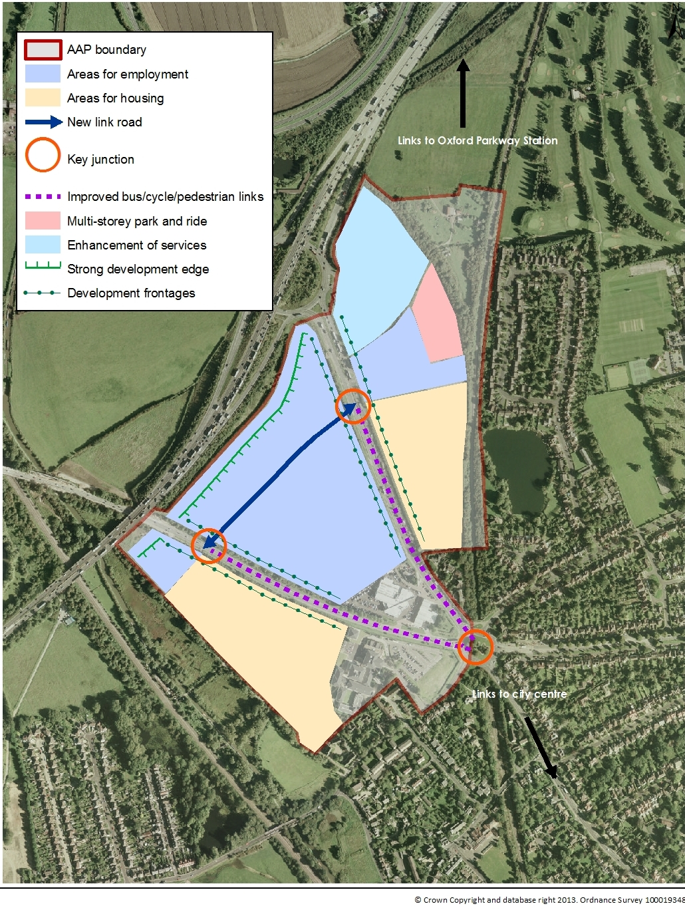

**Implementation and Delivery**

The AAP will address issues of phasing. Development on this scale will be delivered over a period of years in phases. The timing of those phases and the links between phases of development and the delivery of supporting infrastructure will be key to the successful development of the Northern Gateway. It will not be possible for development to take place on this site without the supporting infrastructure (particularly transport measures).

Even after the adoption of the AAP the developers will still be required to submit a planning application for the scheme. It is typical on schemes of this size that an outline planning application will be made for the whole site and then a series of detailed applications are made for individual phases of the development. At each planning application stage there will be a requirement for the submission of more details of the scheme and for additional background evidence on the wide range of topics and there will be additional opportunities for public consultation on those details.

It is important that a range of interests and bodies are involved in planning for, and the development of, the Northern Gateway. These include the City Council and County Council, the various landowners and their development partners, statutory agencies such as the Environment Agency and Natural England, service providers and other stakeholders as well as neighbours and the wider public. The City Council will continue to work closely with the Wolvercote Neighbourhood Forum as they work to produce a Neighbourhood Plan for the wider Wolvercote area.

A partnership approach will be important to finding solutions and identifying packages of mitigation measures to meet the challenges that lay ahead. Equally, working in partnership offers opportunities to bid for funding from a wide range of sources (for example through City Deal) that can be used to collectively pay for the various infrastructure needs of the site and the wider area.

**Next steps**

**How can you influence the process?**

The Options Document offers an opportunity for stakeholders and the general public to contribute to the planning of the Northern Gateway. It is being published to stimulate debate and to invite comments on the options that have been drawn up by the City Council. The City Council hopes that everyone with an interest in the future of the Northern Gateway and the surrounding area – residents, businesses, employees and local organisations – will take the opportunity to respond to this consultation and say what they think about the options contained in this document. We very much welcome your feedback as we are keen that we get the details of this project right and to make the most of the opportunities it offers.

The period for making comments is: 14th February to 28th March 2014

Please make your representations on the form available on the City Council’s website: ([www.oxford.gov.uk/northerngateway](http://www.oxford.gov.uk/northerngateway)), at the council offices and at libraries.

**What happens next?**

Following the consultation, the responses will be considered alongside some further evidence based studies. They will feed into the draft AAP (or Proposed Submission Document) which will also be made available for public and stakeholder comment in July 2014. Following that consultation and any amendments that follow, the AAP will be submitted for examination to the Secretary of State and a public examination of the document will be held, chaired by an independent Planning Inspector.

**How can I keep in touch with progress?**

If you would like to be kept informed of progress towards the AAP you will find regular updates in the following locations:

* In the City Council’s “Your Oxford” magazine
* In the local press
* Through the Wolvercote Neighbourhood Forum
* On the City Council’s website: [www.oxford.gov.uk/northerngateway](http://www.oxford.gov.uk/northerngateway)

You can also register for email or letter updates by joining our consultation database at: [www.oxford.gov.uk/consultation](http://www.oxford.gov.uk/consultation) or by phoning: 01865 252847.

**Appendix – Existing city-wide parking standards**

**Residential parking standards** (Policy HP6 of the Sites and Housing Plan)

|  |  |  |  |  |  |  |  |  |  |  |  |
| --- | --- | --- | --- | --- | --- | --- | --- | --- | --- | --- | --- |
| Number of bedrooms per dwelling | 1 | | 2 | | | 3 | | | 4+ | | |
| Number of allocated spaces  (bold numbers = maximum) | 0 | **1** | 0 | 1 | **2** | 0 | 1 | **2** | 0 | 1 | **2** |
| Number of unallocated spaces (in addition to allocated spaces)* | 1.0 | 0.4 | 1.5 | 0.7 | 0.3 | 1.8 | 0.9 | 0.4 | 2.1 | 1.2 | 0.5 |

*These figures are maxima but are recommended for all developments that involve the creation of a new access road. The minimum requirement for unallocated visitor parking is 0.2 spaces per dwelling.

**Retail parking standards** (Policy TR.3 of the Oxford Local Plan)

|  |  |
| --- | --- |
| Food retail (A1 shops) | 1 space per 50 sq.m. up to 1,000 sq.m; 1 space per 14 sq.m. thereafter |
| Non-food retail: A1 (shops) and A2 (financial and professional services) | 1 space per 50 sq.m. |
| Pubs/ Restaurants/ Cafe's (A3 food and drink) | 1 space per 20 sq.m. public floor space plus, 1 space for resident staff |
| Take-aways/launderettes/off-licences | 2 spaces |

**Business parking standards** (Policy TR.3 of the Oxford Local Plan)

|  |  |
| --- | --- |
| Offices (B1) | 1 space per 35 sq.m. or 1 space per 2 staff |
| General Industry (B2)/Storage and distribution (B8) | 1 space per 35 sq.m. up to 235 sq.m; 1 space per 300 sq.m. thereafter |

1. A Character Assessment of Oxford in its Landscape Setting (2002) Land Use Consultants ([www.oxford.gov.uk/northerngateway](http://www.oxford.gov.uk/northerngateway)) page 283
2. Validity of Employment Land Review Estimates (2010) Nathaniel Lichfield and Partners (<http://www.oxford.gov.uk/Direct/CoreStrategyCD1427aOxfordEmploymentLandStudyUpdateNote.pdf>)
3. The Oxfordshire Innovation Engine (2013) SQW (<http://www.sqw.co.uk/file_download/411>); paragraph 7.23
4. Oxfordshire Housing Market Assessment (2007) (<http://www.oxford.gov.uk/Direct/7709527OxfordshireHousingMarketAssessment.pdf>)
5. For more details see Sites and Housing Plan ([www.oxford.gov.uk/sitesandhousing](http://www.oxford.gov.uk/sitesandhousing))
6. Northern Gateway Baseline Transport Report (2013) PBA ([www.oxford.gov.uk/northerngateway](http://www.oxford.gov.uk/northerngateway))
7. Northern Gateway Baseline Transport Report (2013) PBA ([www.oxford.gov.uk/northerngateway](http://www.oxford.gov.uk/northerngateway)) page 27
8. Found for example in By Design, Better Places to Live by Design and the Oxford Local Plan
9. paragraph 79 of the National Planning Policy Framework
10. Inspector’s Report paragraph 4.147 ([www.oxford.gov.uk/Direct/CoreStrategyFinalInspectorsReport.pdf](http://www.oxford.gov.uk/Direct/CoreStrategyFinalInspectorsReport.pdf))
11. ([www.jncc.defra.gov.uk/protectedsites/sacselection/sac.asp?EUCode=UK0012845](http://www.jncc.defra.gov.uk/protectedsites/sacselection/sac.asp?EUCode=UK0012845))
12. A Character Assessment of Oxford in its Landscape Setting (2002) Land Use Consultants ([www.oxford.gov.uk/northerngateway](http://www.oxford.gov.uk/northerngateway)) p283